John Vos & James Shaw

  OBJECT ORIENTED SOFTWARE ARCHITECTURE, DESIGN AND IMPLEMENTATION

assignement 2

Contents

Use Case Modelling: 2

Use Cases: 4

Use Case 1 (John Vos): 4

Use Case 2 (James Shaw): 5

UML: 6

Contribution: 7

# Use Case Modelling:

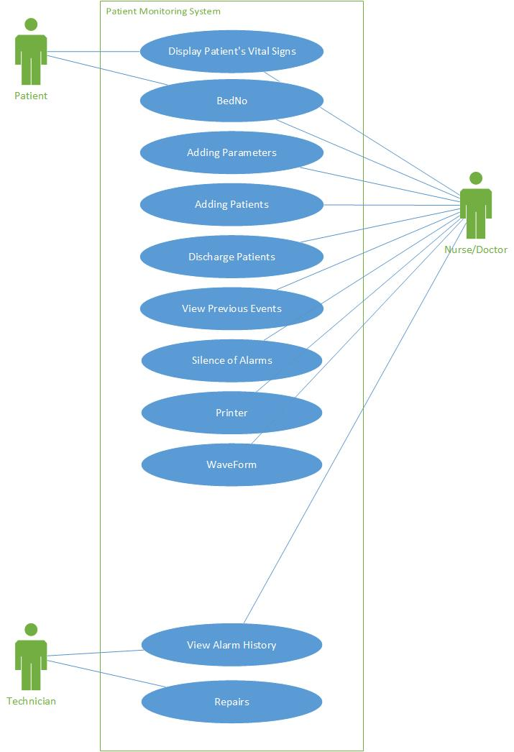

# Use Cases:

## Use Case 1 (John Vos):

**Use Case:**

Display Patient Vital Signs

**Primary Actor:**

Patient

**Secondary actors:**

Nurse / Doctor

**Goal:**

To display patients vital signs.

**Preconditions:**

Patient is added to system.

**Success End Condition:**

The patient's vital signs are displayed within safe ranges.

**Failed End Condition:**

Vital Signs are not displayed.

**Trigger:**

The patient's vital signs are not within safe ranges.

**MAIN SUCCESS SCENARIO**

1. Patient is admitted to hospital

2. Patient is hooked up to display monitor by a nurse or doctor.

3. GOBBLY

4. GOOP

5. Patient produces discharge

**EXTENSIONS**

<put here the extensions, one at a time, each referring to the relevant step of the main scenario>

<step altered><condition>:<action>

## Use Case 2 (James Shaw):

**Use Case:**

Adding Patients

**Primary Actor:**

Doctor/Nurse

**Secondary actors:**

Patient

**Preconditions:**

The patient has been admitted into the ward

**Success End Condition:**

All relevant data about the patient is on the system

**Failed End Condition:**

The patient is missing data on the system

**Trigger:**

Patient is admitted to the hospital ward

**MAIN SUCCESS SCENARIO**

1. Patient is admitted into the ward
2. Information about the patient is collected from database
3. Relevant information such as normal blood pressure for this patient is added to the monitoring system
4. Information is displayed on the central console ready to the patient to be set up at an individual station

**EXTENSIONS**

<put here the extensions, one at a time, each referring to the relevant step of the main scenario>

<step altered><condition>:<action>

# UML:

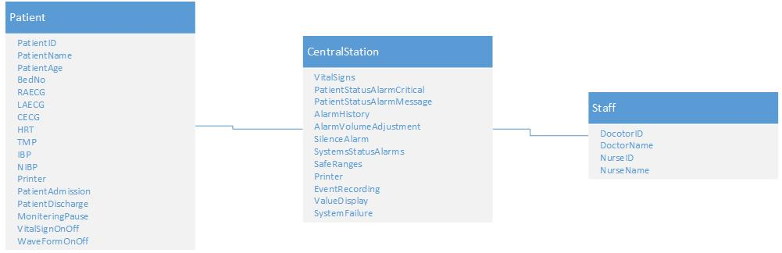

# Contribution:

|  |
| --- |
| **Student Name:**  James Shaw  17848280  **Contribution Summary:**  Use Case Modelling  Use Case 2  UML |
| **Student Name:**  John Vos  17806554  **Contribution Summary:**  Use Case Modelling  Use Case 1  UML |